# COMPILER DESIGN ASSIGNMENT 3

def DFA():

    string =input("Enter String over alphabet{0-9} : ")

    state=0

    n=len(string)

    if (n==0):

        print("Empty String \u03B5")

        return None

    mod_0=['0','3','6','9']

    mod_1=['1','4','7']

    mod_2=['2','5','8']

    for i in string:

        if (state==0):

            if i in mod_0: state=0

            elif i in mod_1: state=1

            elif i in mod_2: state=2

        elif (state==1):

            if i in mod_0: state=1

            elif i in mod_1: state=2

            elif i in mod_2: state=0

        elif (state==2):

            if i in mod_0: state=2

            elif i in mod_1: state=0

            elif i in mod_2: state=1

    if (state==0):

        print("Given string is accepted at state : ",state)

    else:

        print("Given string is rejected at state : ",state)

DFA()

def PDA():

    string = input("Enter any string over given alphabet{0,1} : ")

    n=len(string)

    if (n==0):

        print("Empty String \u03B5")

        return None

    stack,state,flag=[],0,True

    for i in string:

        if state==0:

            if i=='0' or i=='1': stack.append(i)

            elif i=='C' or i=='c':

                state=1

                continue

        elif state==1:

            if (len(stack)>0 and i==stack[-1]): stack.pop()

            else:

                flag=False

                break

    if (len(stack)==0 and flag==True):

        state=2

    if (len(stack)>0):

            print("Stack top : ",stack[-1])

    else:

            print("Stack top : ","Empty")

    if (state==2):

        print("String is accepted at state : ",state)

    else:

        print("String is rejected at state : ",state)

PDA()

**Output of Task A: Design and Implementation of a Finite State Machine (FSM) to Recognize Strings Divisible by 3.**

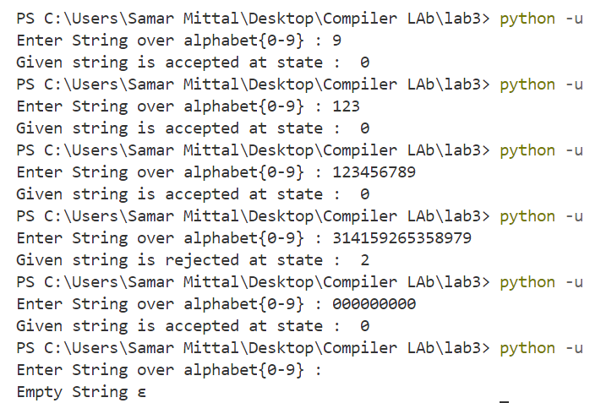

**Output of Task B: To design and simulate a Pushdown Automaton (PDA) for the language L, which recognizes strings in the form WCW^R,**

